## horizontal line



Event spot

Ishika patel

Kirat Singh

Katrina Lieu

Prathna Rajput

**─**

# Overview

Consider your event website to be your online agent, acting as a link between you and your customers. Your online presence is the deciding factor for potential clients in deciding whether or not to hire you. In short, the way you present your brand on your website has a greater impact than you may realize. Those who strategically design their website can reap the benefits and build a loyal following. As a result, a poorly designed event website can be a deal-breaker for your business, especially if you're just getting started and don't yet have a good reputation.

We are designing and developing a social Web Application that allows users to plan events and compare calendars to find a suitable time/date for that gathering. The inspiration we took for this

# Goals

The web application must use NodeJS, Express, and AJAX .

The database must be a SQL database.

Your markup/code must pass W3C Validation and ESLint linting.

You may use other libraries/frameworks not addressed in this course, however:

* + Remember that you're working in a group; all group members are expected to have contributed to and understand the work developed.
  + Your implementation must still demonstrate your understanding of the concepts taught in this course.
  + We may be unable to mark work that deviates too much from the course content.

# Specifications that need to be included

1. To create a:
   1. User should be able to sign up and log in to the system in order to
      1. Sign up/login
      2. Manage their users information
      3. Create a new event.
      4. Generate a link for people with an account
      5. Specify their availability for an event
      6. Confirm/finalize an event time.
   2. System Admins their user information
      1. Manage their user information
      2. Mange User
      3. Mange Events
      4. Sign-up other Admins
   3. Users should be able to choose to link an email, allowing login via that platform, to make logging in easier.
   4. Users without accounts should be able to specify their availability for an event provided by a custom link.
   5. Email notification.
      1. User can request that email notification be sent to them that includes updates when users respond, availability is confirmed, the event is finalized, or the event is can

# Design

## Home page

The main page will include a transition of images. There will be an about us, log in, sign up, and home page option top right hand corner. After clicking on the option it will take you to the page that has been selected.

The main page will also have the logo present at the top right hand corner of the page

. 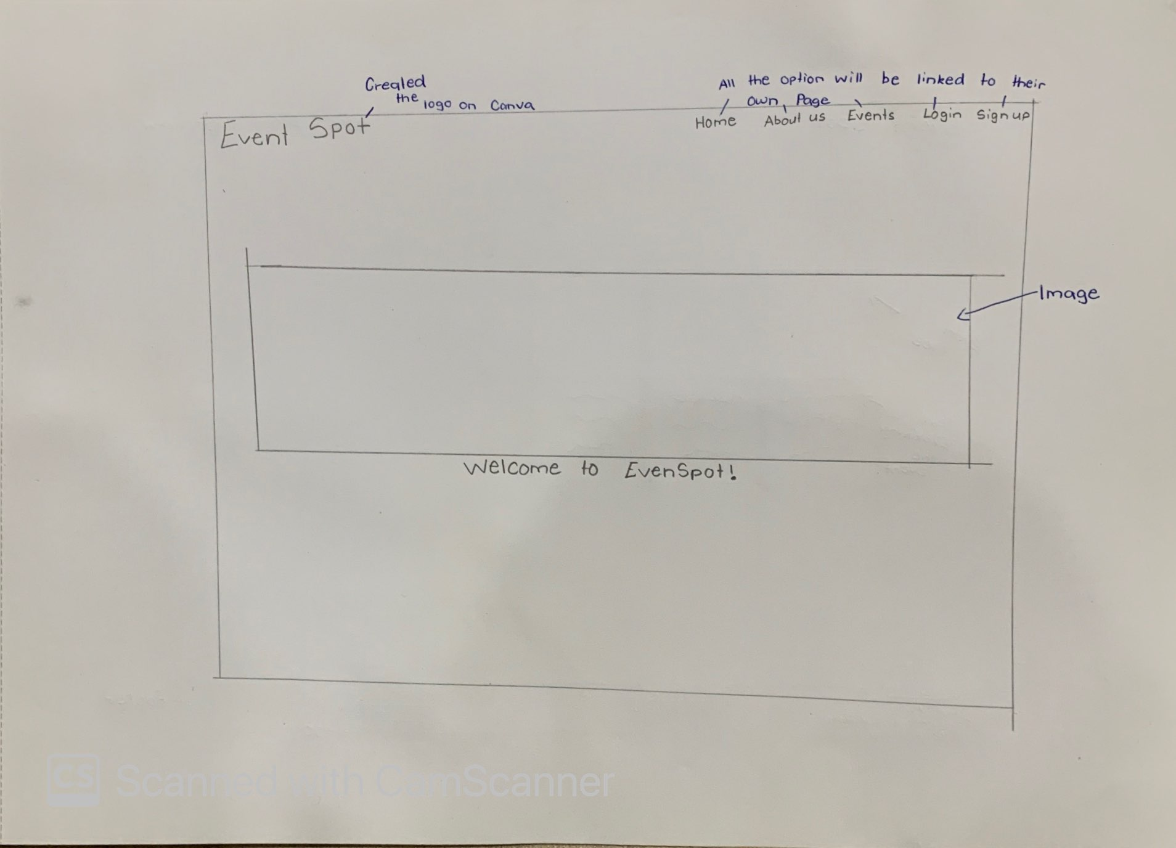

As the home page is the first thing you see we wanted to add some features to them. Even though our initial design was simple and not much on the page we ended up adding much more features to it. As i have mentioned before the animation. Which took a lot of research.

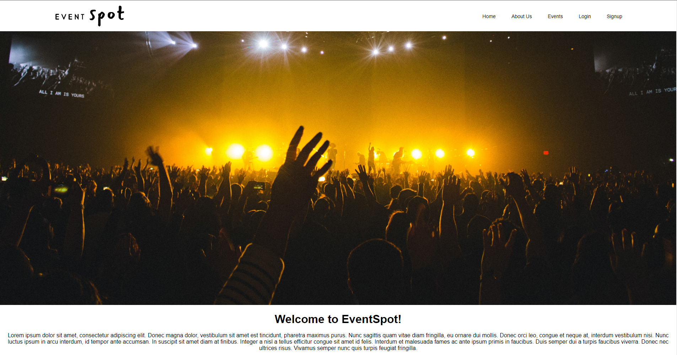

## Events page

The events page will appear after pressing the button on the top right hand corner. The page consists of a number of events you can register for. This information will be stored in the databases. An account will be needed to register for events.

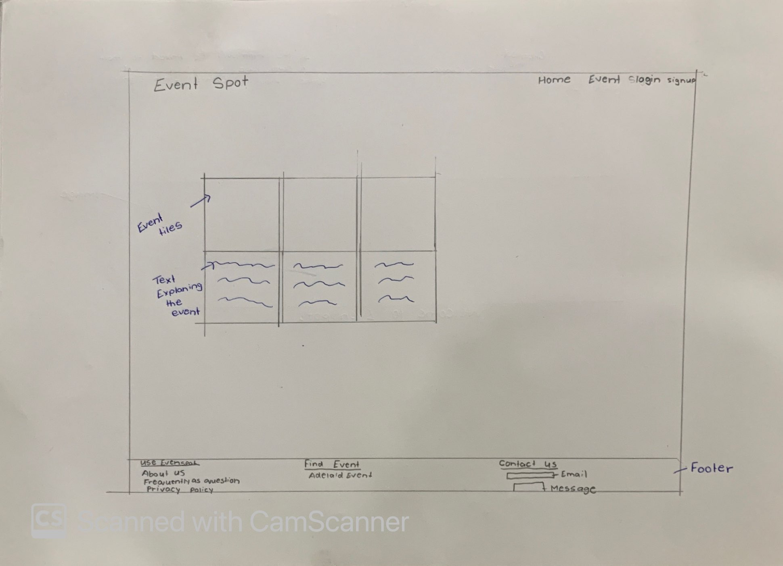

For the event page there were different ways to do it. For the sketch we decided to keep it really simple so we have a room to grow and explore new things like if we wanted to have our event tiles expand when we moved the mouse on to it. Also this design includes the footer. As you can see its show is simple but when we came to implement it the underlines are animations.

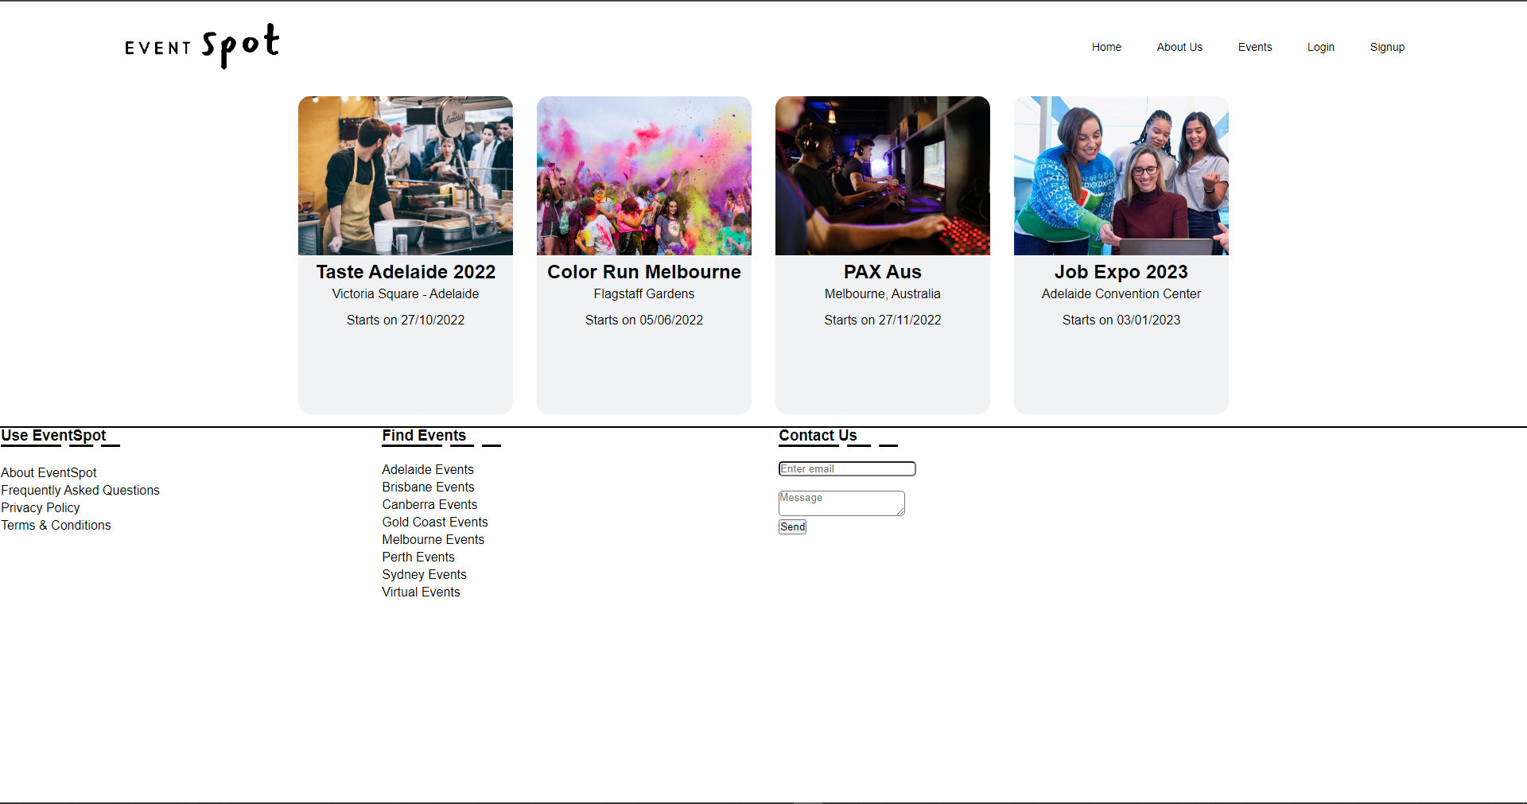

## Sign up/login page

The sign up page will appear after pressing the button on the top left hand corner. The page contains a space to enter your email address in, password and also a re enter your password. This information will be stored in the databases. In some cases you might already have an account and accidentally clicked the sign in option that you can just press cancel and return to the main page.

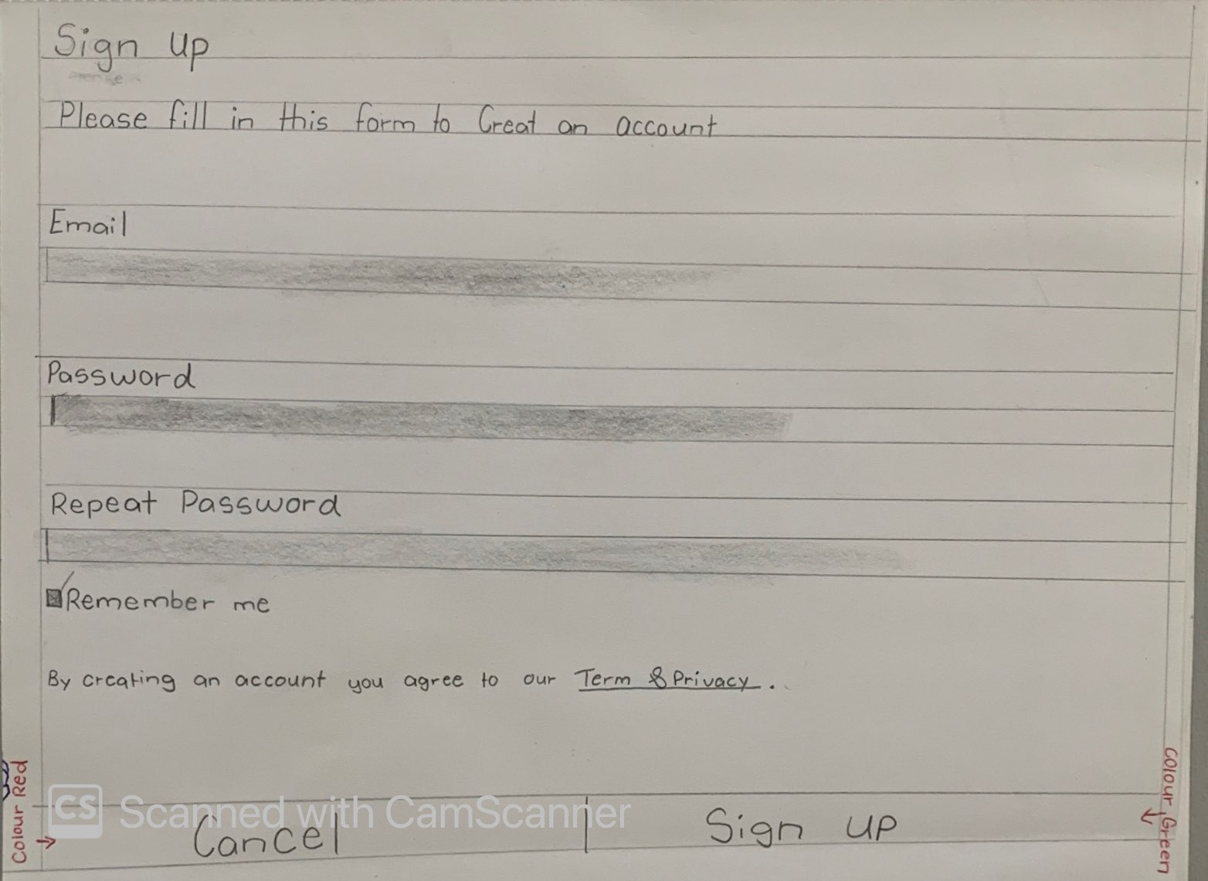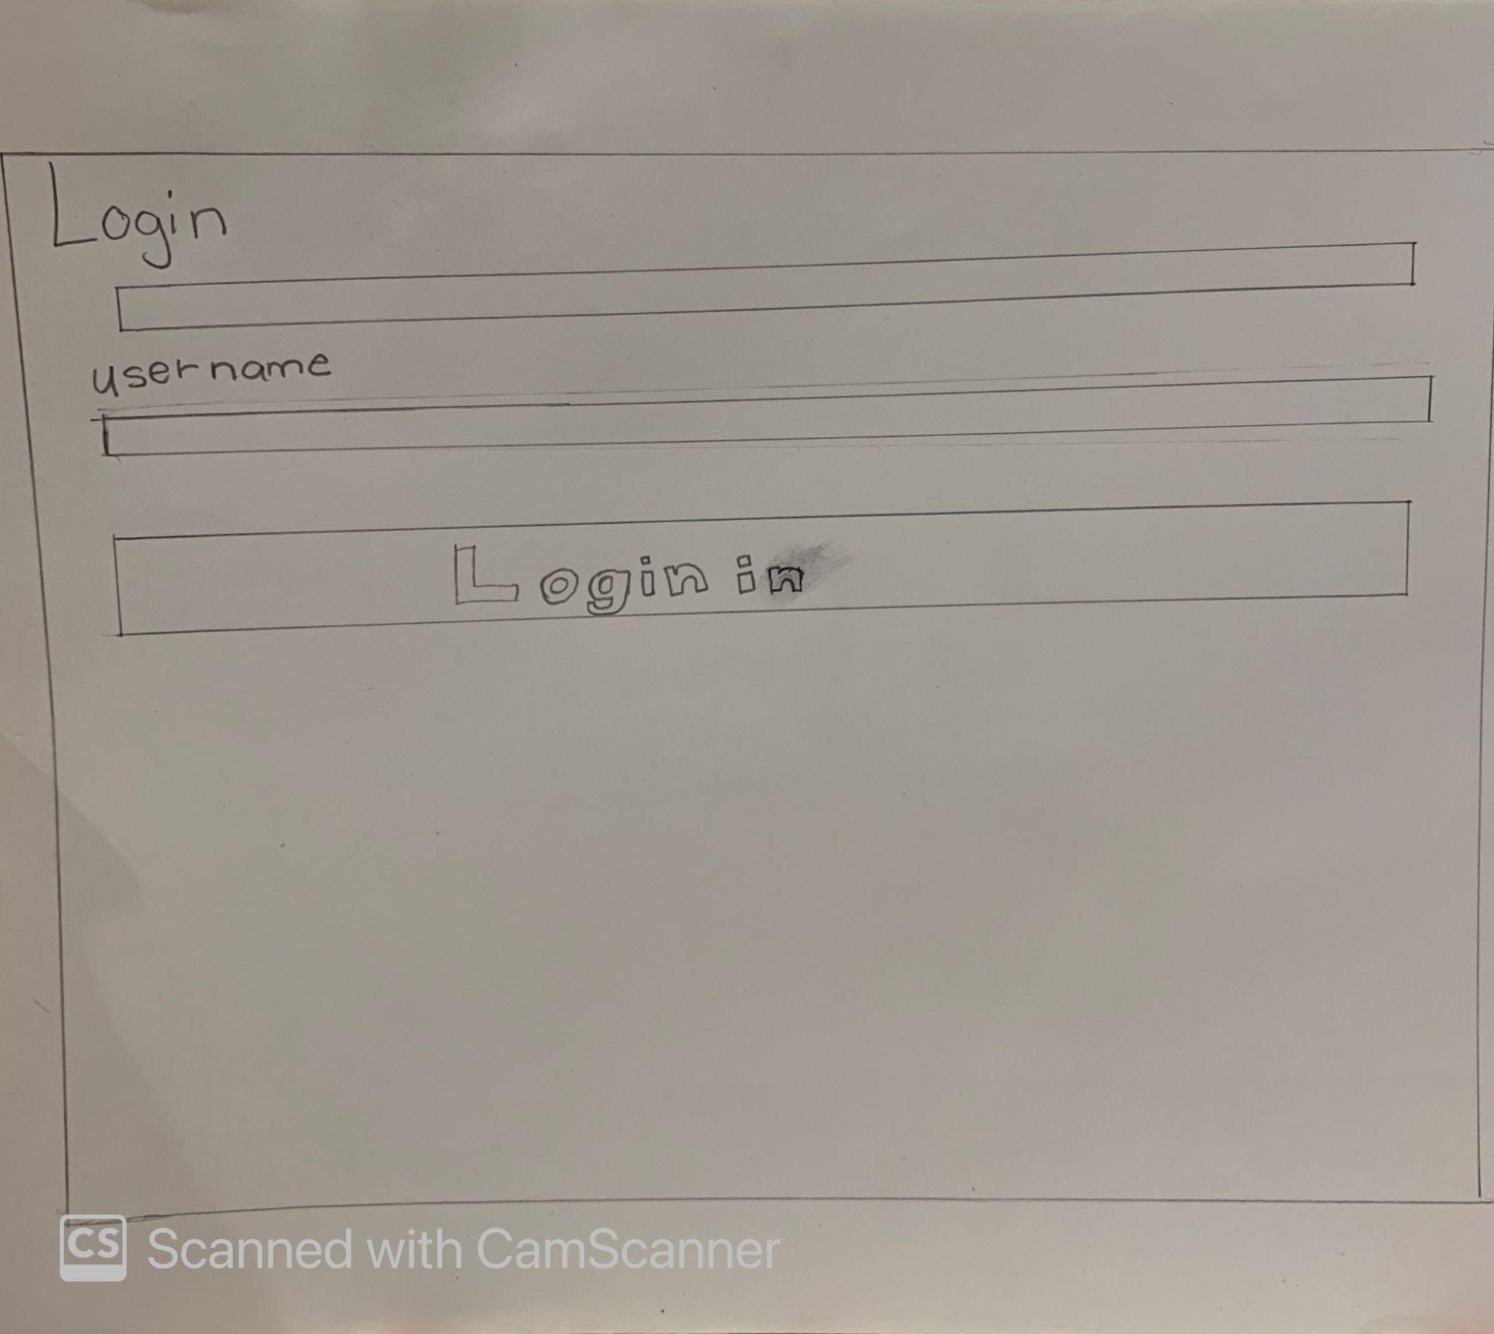

This was our initial design. When we started thinking about our layout we visited multiple websites to see which one looked appling. We started with the basics and then built on it. The image below shows a screenshot of what our sign up page ended up looking like.

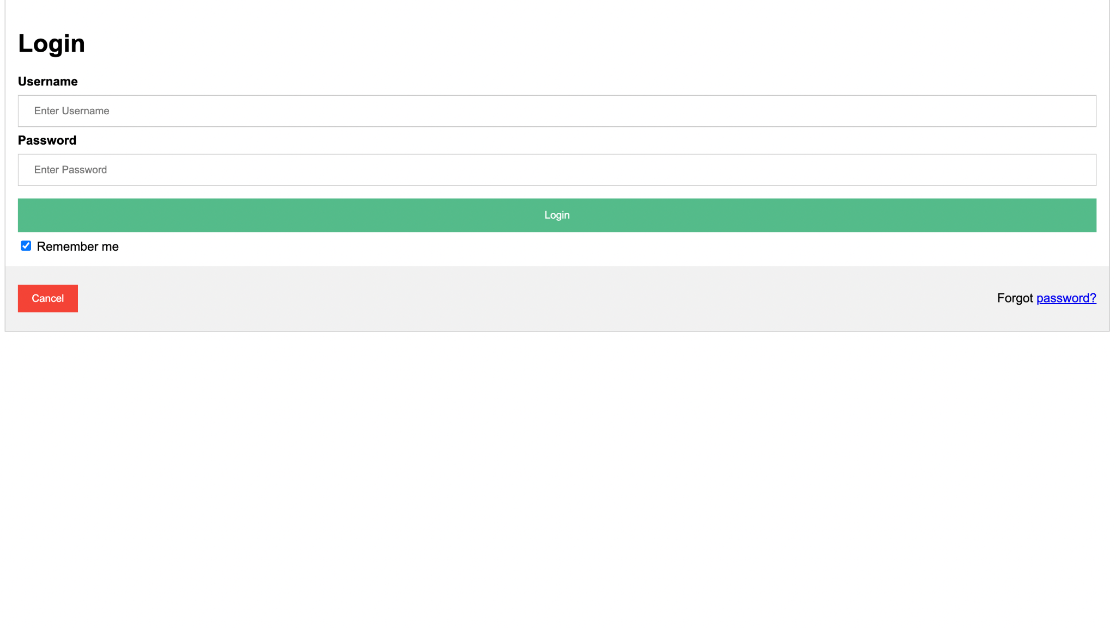

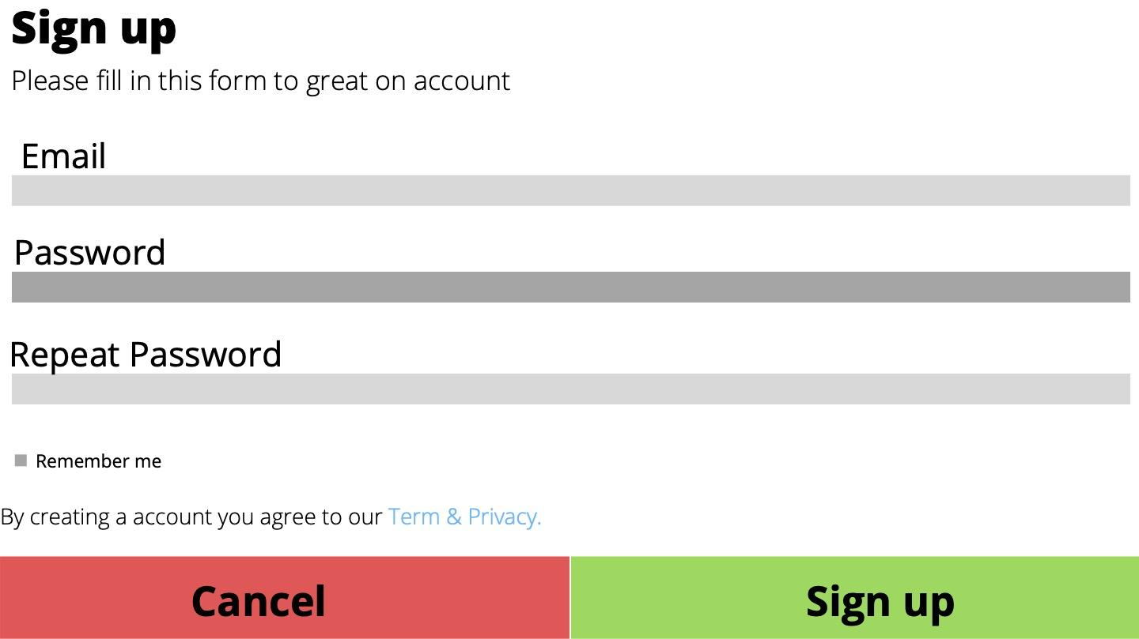

# Database scheme

# 

# Features

As you open up the home page you would see an option to the top right hand corner.

About Us:

When you click on the option the about us page it will take you to a different page

where the title and a paragraph on what Spot does.

Login:

The login page contain where you can put your email and password in an also has

An option to say remember me and also if they have forgotten my password.

Sign up:

The sign up page has space to put their email in, also password and re password.

Just like the login the sign up also remembers me.

Event:

The page contains event tiles. Which include information about upcoming events.

You can click on the tile and it will give you more information about the event.

# Milestones

## Milestone 1 Submission

Milestone 1 was achieved by us by finalizing the client end of our websites. Some parts such as the login and signup page are to be looked at again since we will be redesigning them. Our website inspiration was gained from a famous social event website, Eventbrite. Different tutorials were also looked at to gain inspiration and to learn new things.

## Achieve

* + Ishika:
    - The login page
    - The sign up page
  + Kirat
    - The home page
    - About us page
    - The header
  + Katrina
    - The footer

## 